Tasks | dated 14-10-2026

Task 1: Install nginx and run nginx on port number 81.
Steps:
- Updated system packages using dnf update -y.
- Installed Nginx using dnf install nginx -y.
- Edited /etc/nginx/nginx.conf and changed the listening port from 80 to 81 for IPv4 and IPv6.
- Validated the configuration using nginx -t and restarted Nginx using systemctl restart nginx.
- Verified that Nginx was listening on port 81 and accessed it through an external browser after configuring the EC2 Security Group.
Evidence:
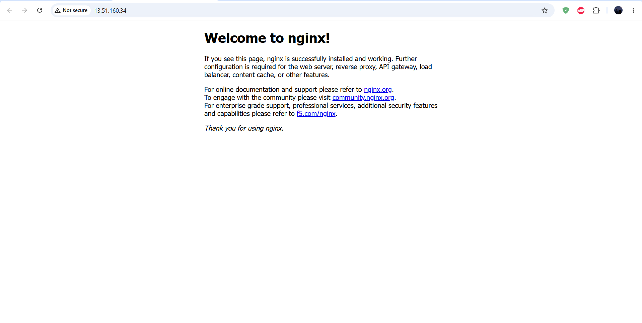
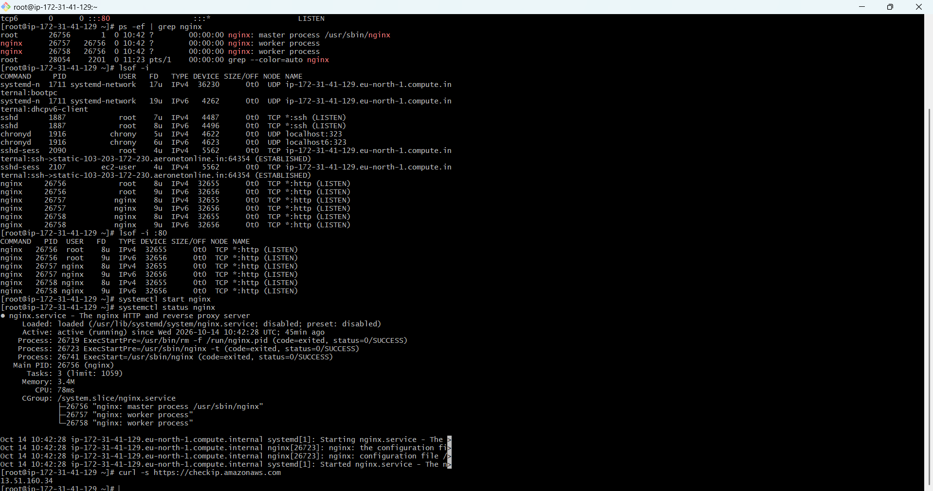
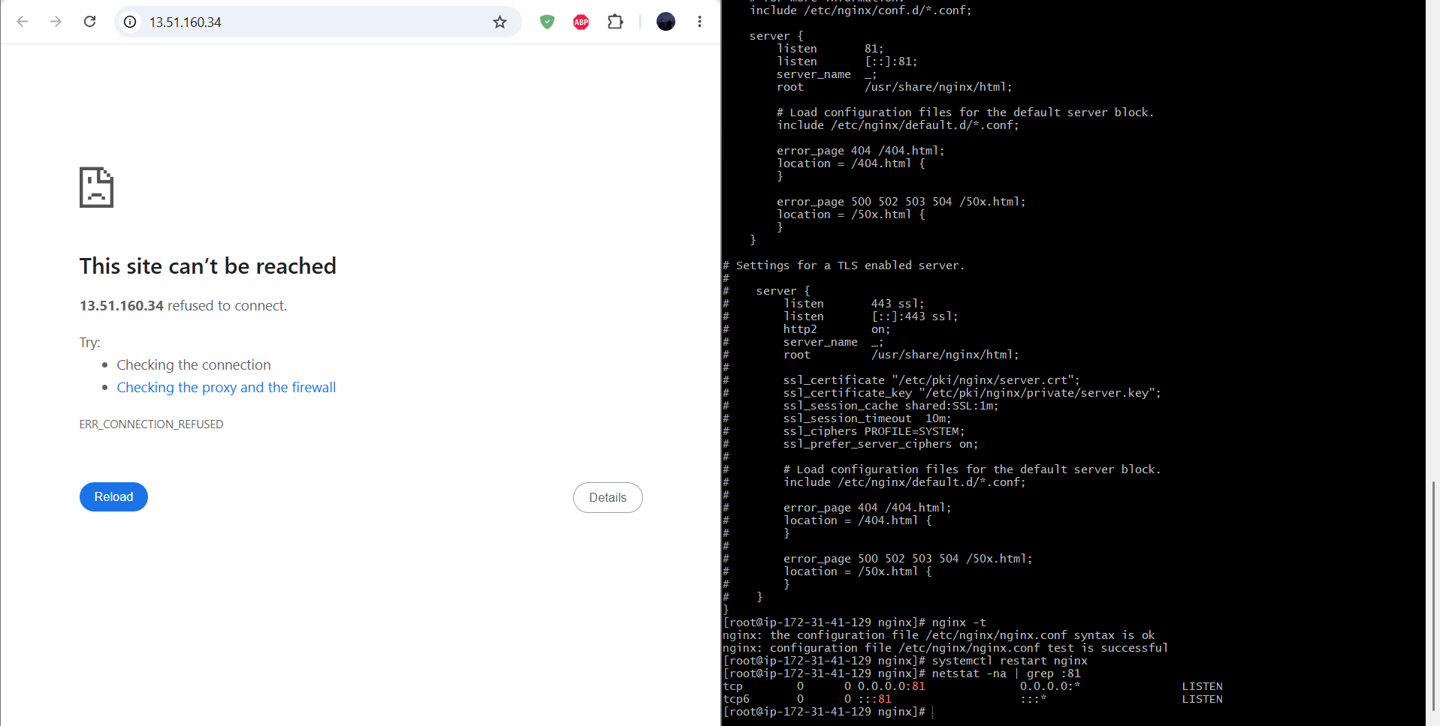
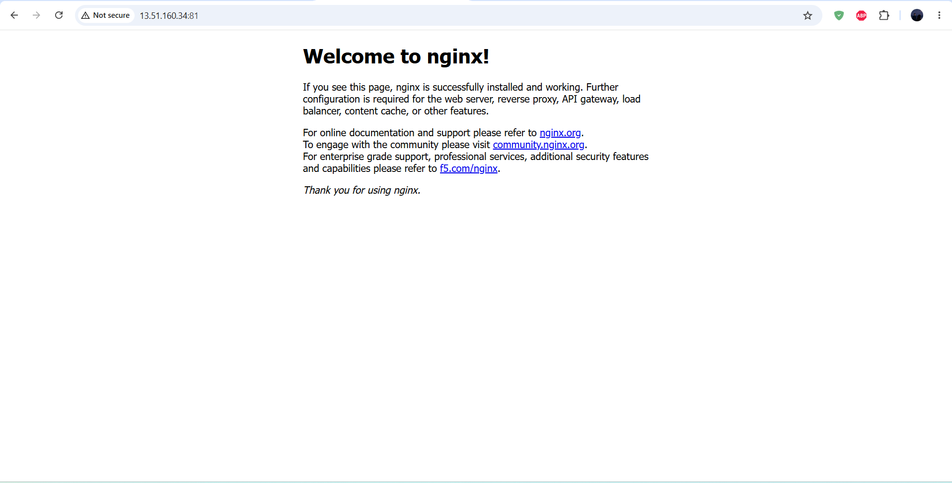
Task 2: Deploy a sample index.html file on nginx.
Steps:
- Identified the Nginx document root as /usr/share/nginx/html/.
- Created a custom index.html file in the document root.
- Added sample HTML content with a heading and descriptive text.
- Accessed the EC2 public IP using port 81 to verify the deployment.
- Confirmed that the custom webpage was displayed successfully in the browser.
Evidence:
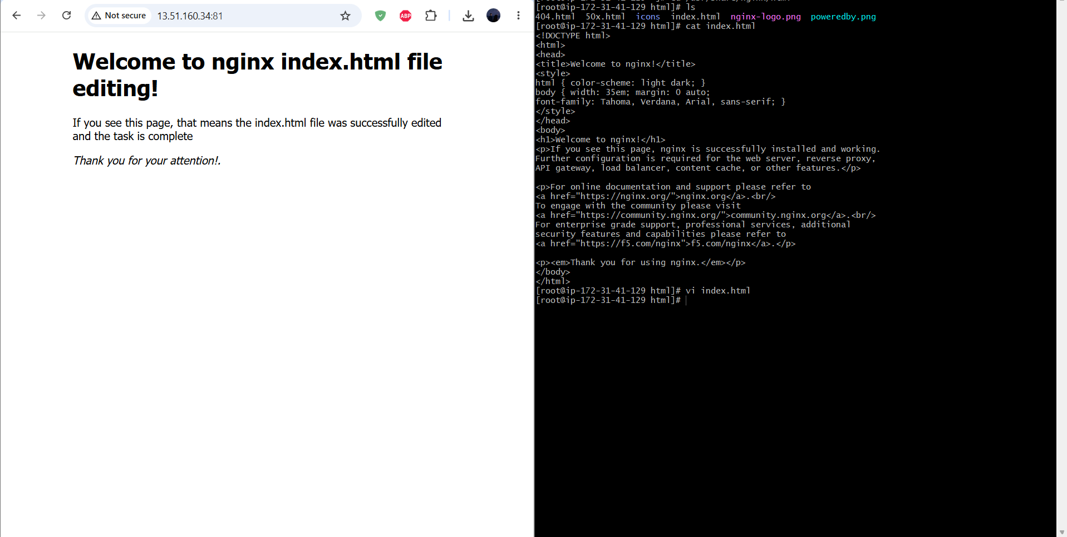

Task 3: Install Apache and run Apache on port number 82
Step:
- Installed Apache HTTP Server using dnf install httpd -y.
- Edited /etc/httpd/conf/httpd.conf.
- Changed the Apache listening directive from Listen 80 to Listen 82.
- Validated the configuration using httpd -t and started Apache using systemctl start httpd.
- Verified that Apache was listening on port 82 and configured the EC2 Security Group to allow external access.
Evidence:
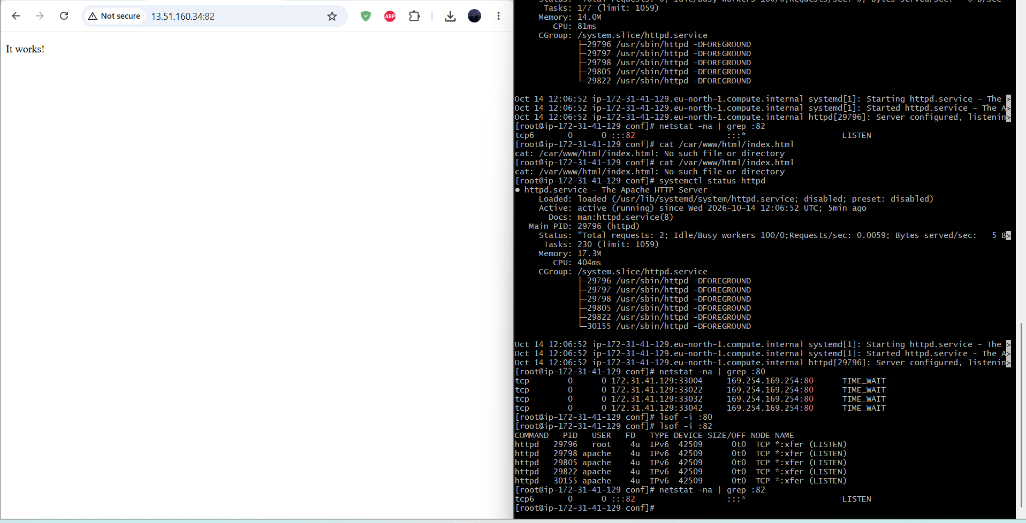
Task 4: Deploy a sample index.html file on Apache.
Steps:
- Identified Apache's document root as /var/www/html/.
- Created a custom index.html file in the document root.
- Added sample HTML content describing the Apache server and its port.
- Opened the EC2 public IP using port 82 in an external browser.
- Verified that the custom Apache webpage was displayed successfully.
Evidence:
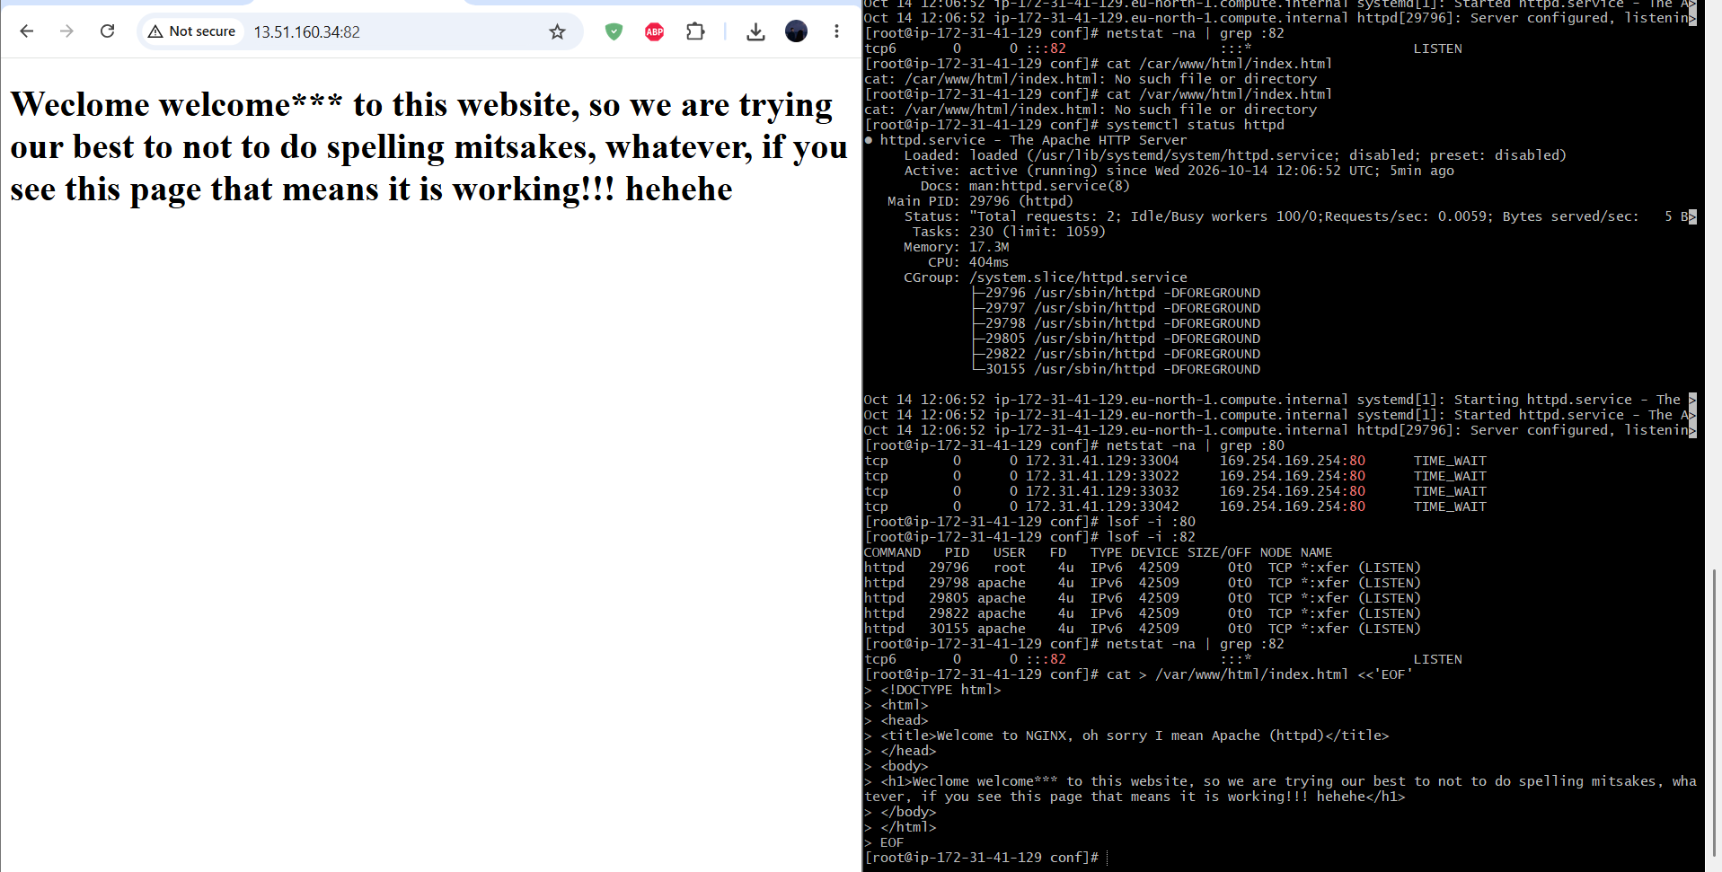
Task 5: Install Apache tomcat on port number 8082
Steps:
- Installed Java 21 using dnf install java-21-amazon-corretto-headless -y and verified it using java -version.
- Downloaded and extracted Apache Tomcat 10.1.61 under /opt/.
- Edited /opt/apache-tomcat-10.1.61/conf/server.xml and changed the HTTP connector port from 8080 to 8082.
- Started Tomcat using ./startup.sh from its bin directory and verified the listening port.
- Configured the EC2 Security Group and accessed the Tomcat welcome page through port 8082.
Evidence:
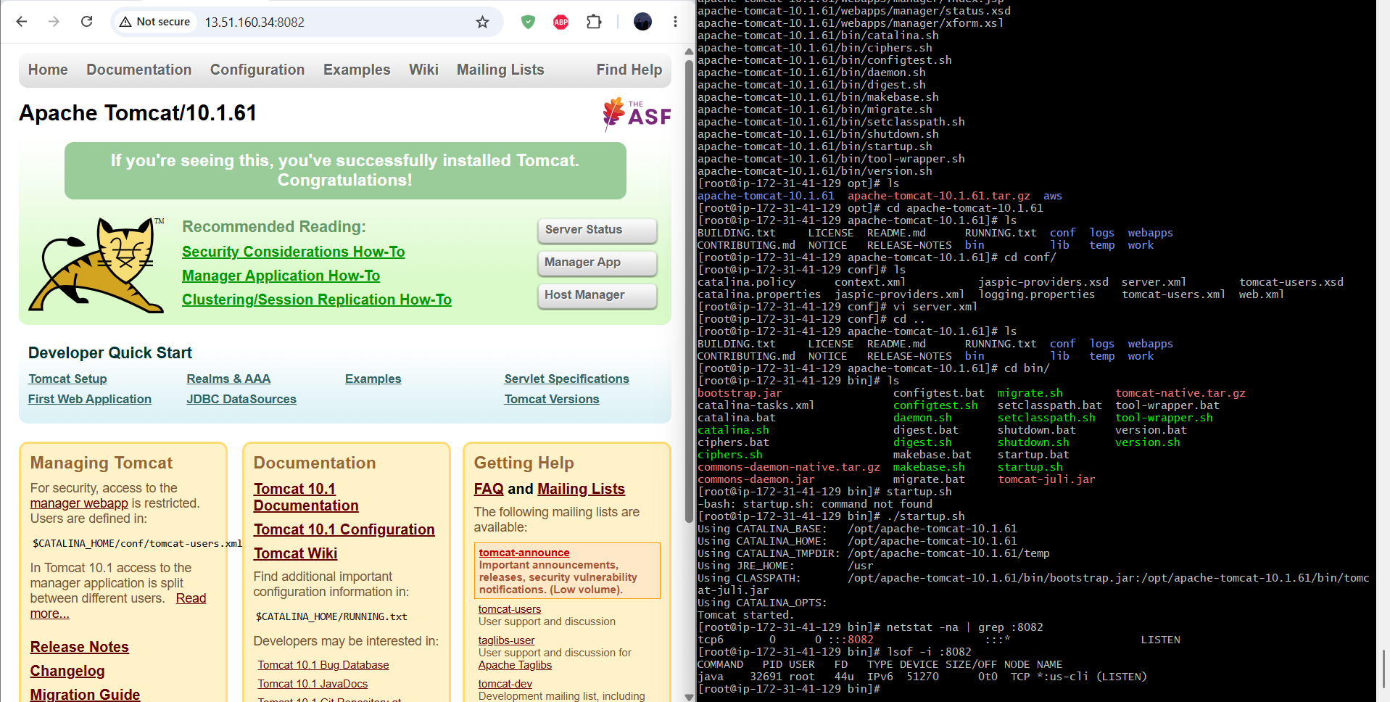
Task 6: Deploy a sample app on webapps
Steps:
- Navigated to /opt/apache-tomcat-10.1.61/webapps/.
- Created an application directory named myapp.
- Created an index.html file inside the myapp directory.
- Added sample HTML content describing the application deployment.
- Verified the application in the browser at http://EC2-PUBLIC-IP:8082/myapp/
Evidence:
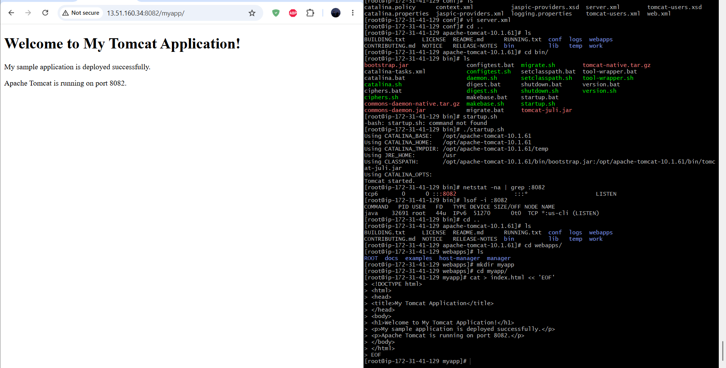
Task 7: Create a tomcat.service file for tomcat.
Step:
- Created /etc/systemd/system/tomcat.service using the vi editor.
- Configured the service description, Java environment, and Tomcat installation paths.
- Defined ExecStart and ExecStop using Tomcat's startup.sh and shutdown.sh scripts.
- Reloaded systemd using systemctl daemon-reload and enabled Tomcat using systemctl enable tomcat.
- Started Tomcat through systemd and verified the service using systemctl status tomcat.
Evidence:
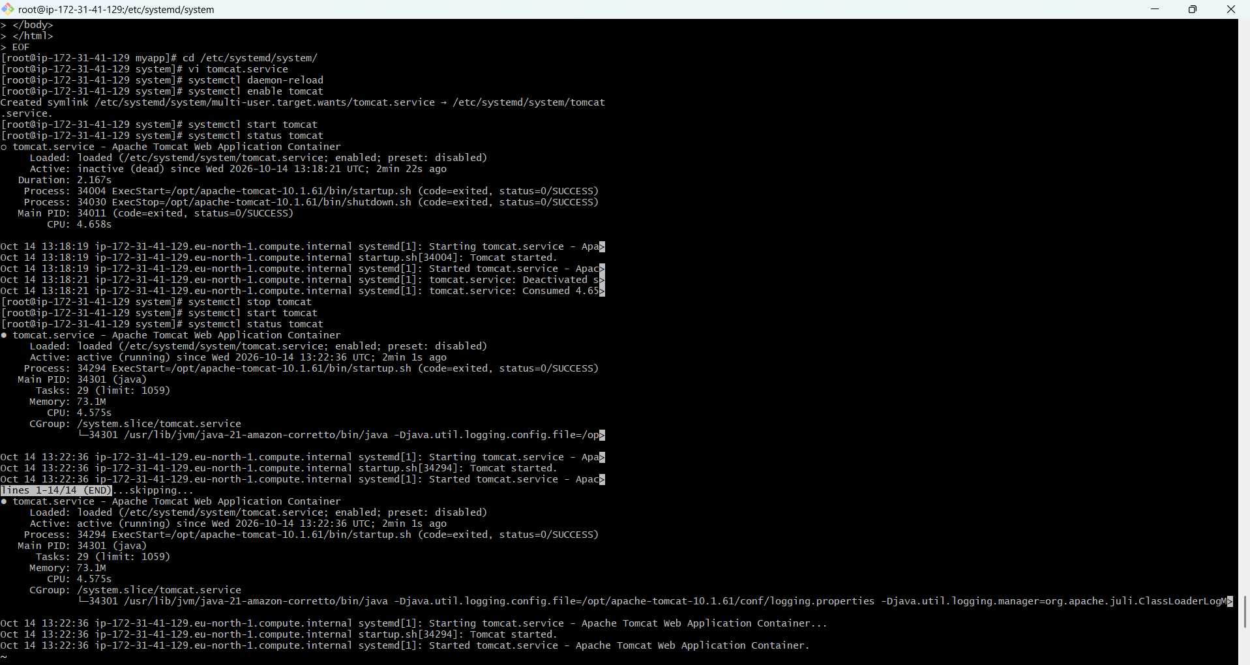
Task 8: Configure HA Proxy server
Steps:
- Installed HAProxy using dnf install haproxy -y.
- Backed up the original configuration file at /etc/haproxy/haproxy.cfg.
- Edited the HAProxy configuration to define a frontend listening on port 80 and a backend pointing to Nginx on 127.0.0.1:81.
- Validated the configuration using haproxy -c -f /etc/haproxy/haproxy.cfg and started HAProxy using systemctl start haproxy.
- Verified that HAProxy was listening on port 80 and tested the reverse proxy through the EC2 public IP.
Evidence:
